**KALI LINUX BASIC COMMANDS**

**Exp No:01**

**Aim :**

To perform all basic commands in Kali linux OS.

**Procedure :**

1.Install Virtual Box.

2.Add Kali linux Machine.

3.Open the Terminal of Kali Linux.

4.Then perform all the basic commands in Terminal.

**Output :**

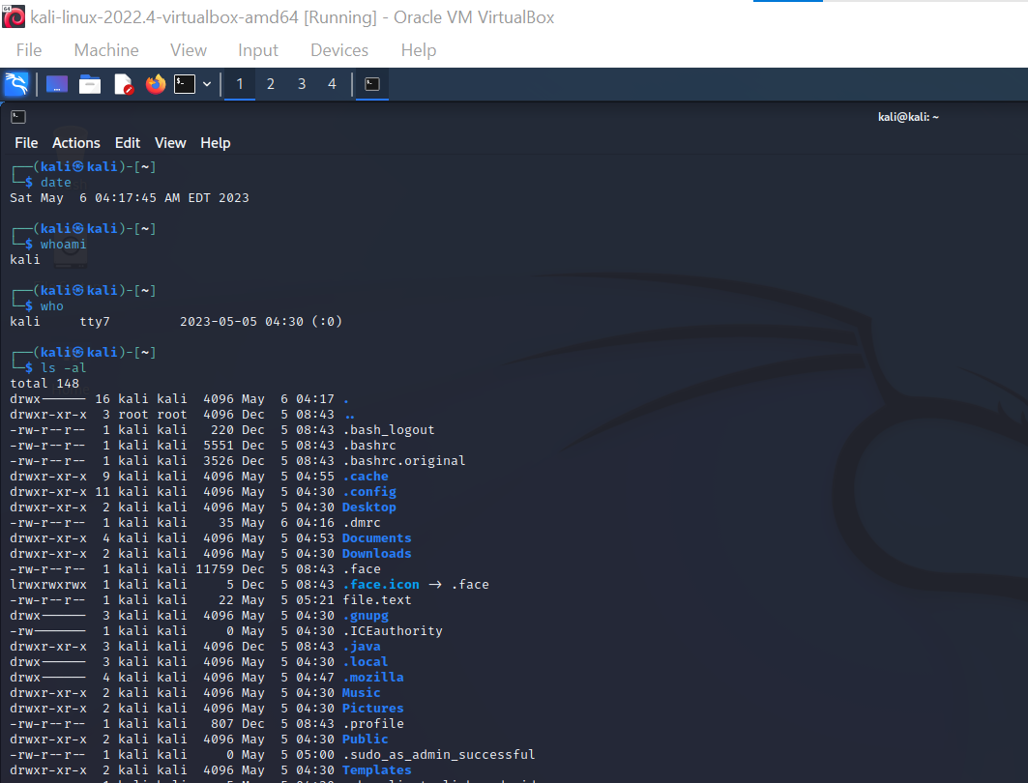

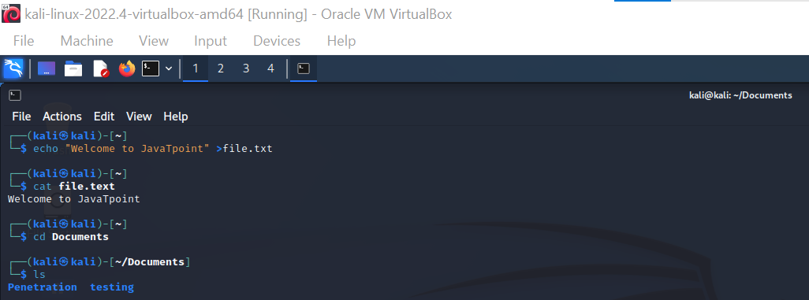

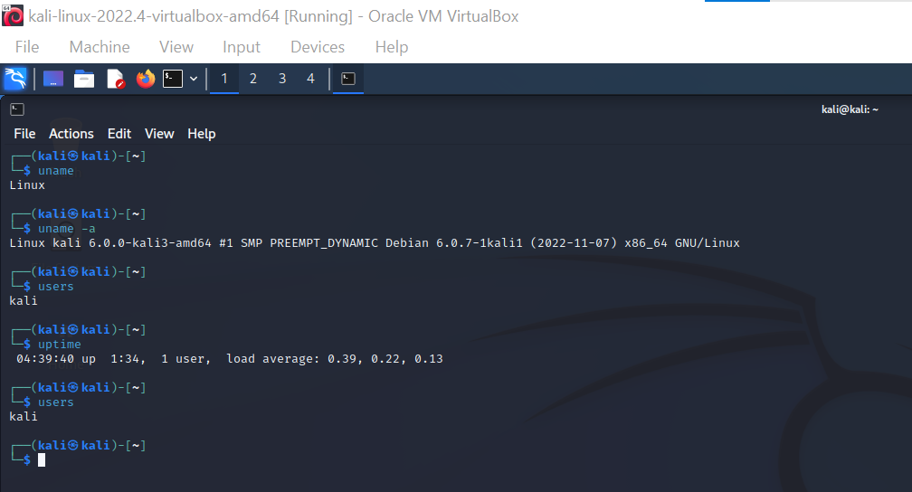

Less Command

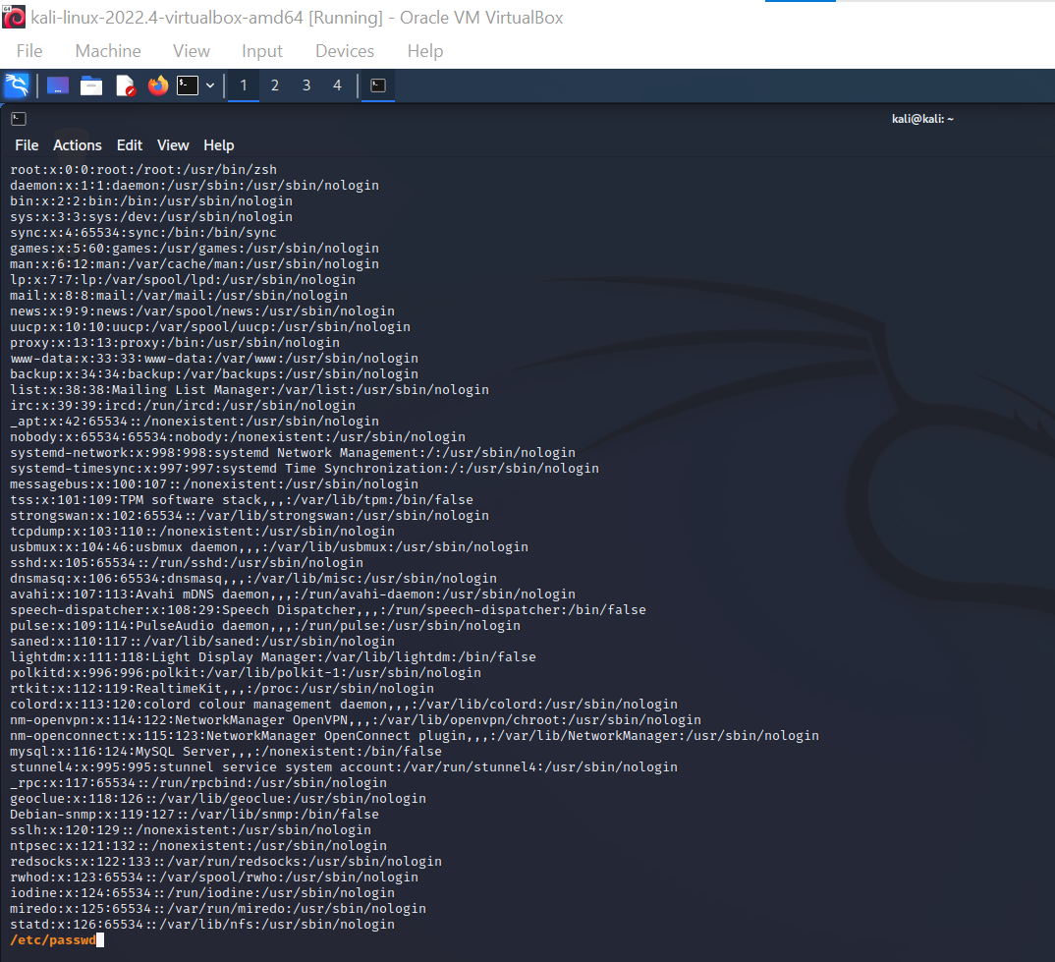

More Command

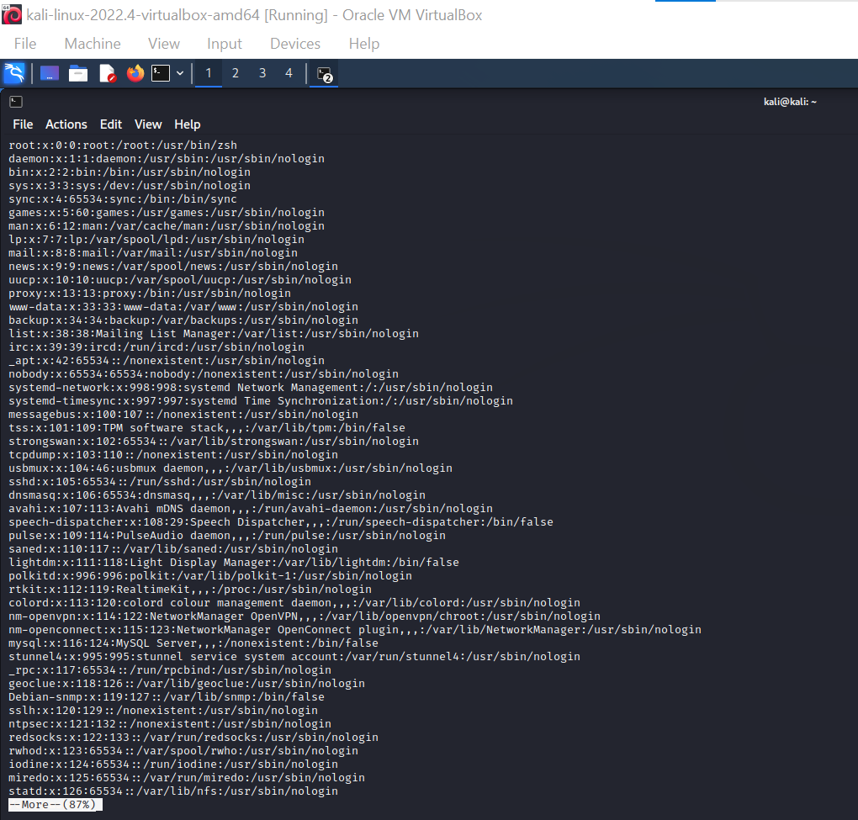

Vi Command

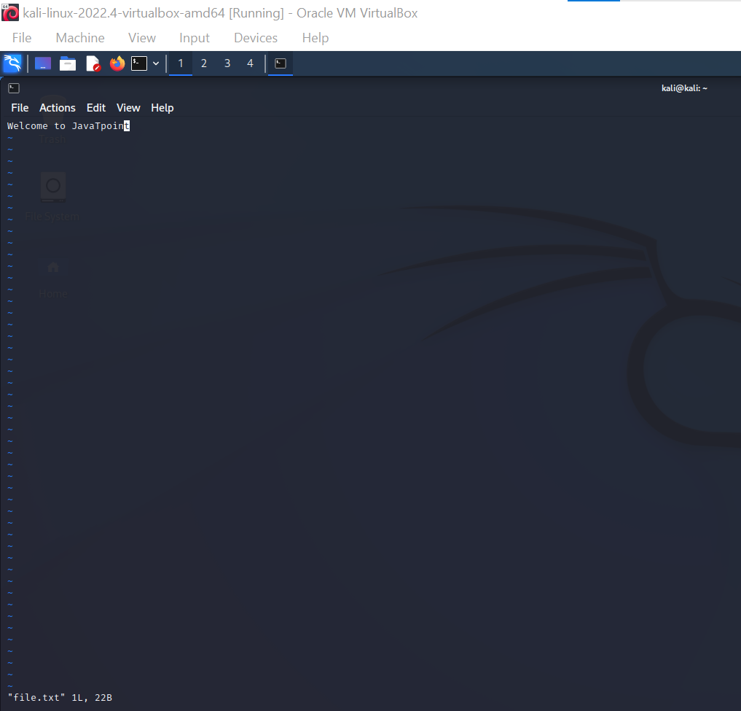

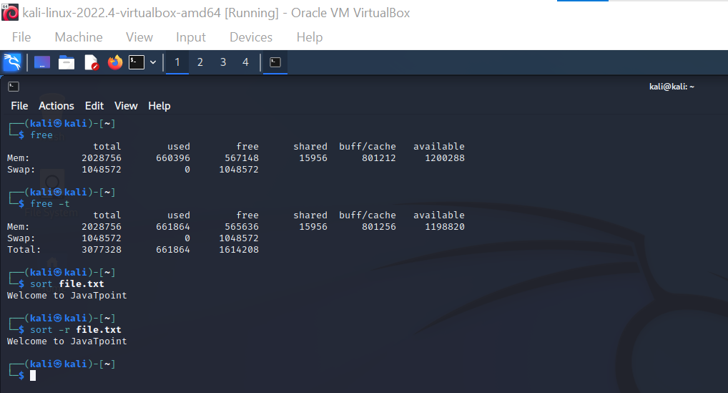

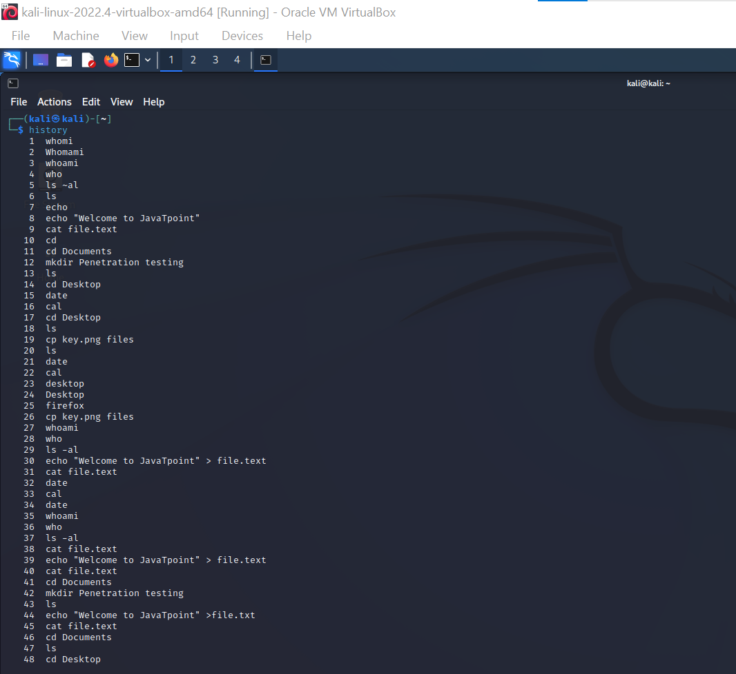



**Result :**

Hence all the basic commands of kali Linux is Executed Succesfully.